Name: Chang Qi Jia Student No: 5280618

Step 1: Use a CV curve tool to draw a rough sketch of the track

Step 2: Use the control vertex of the graph to shape the track

Step 3: Duplicate the curve and adjust the duplicated curve to be above the original curve, this would serve as a locator path

Step 4: Create a locator and set the locator path as the constrain motion path.

Step 5: Change the start time to 1 and the end time to 200

Step 6: Create a portion of the track and set the original curve as the constrain motion path. When creating the track take note that it will be connected to duplicates of itself later and thus the ends should not have any faces. Also, if using a cylinder polygon as the tracks, prevent using too many subdivisions as the bridging process will take a long time

Step 7: Set the World up Type as Object up and enter the locator name as the world up object, this would make the track “look at “the locator as it moves

Step 8: Change both the locator and the track animation graph as tangent

Step 9: Go to Visualize -> Animation Snapshot to duplicate the tracks

Step 10: Connect the tracks together and shape it accordingly.

Step 11: Create a cart and set it to the path

Step 12: Duplicate the cart to produce the 3 carts required.

Step 13: Animate the carts, this can be done by combining them into an object and setting the original curve as the motion path, however this will result in very rigid 3 carts. Another method would be to animate the carts separately.

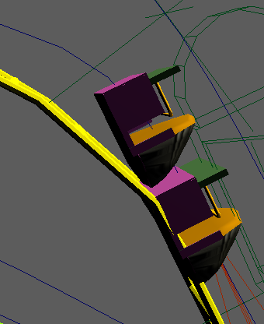 <- Rigid Cart 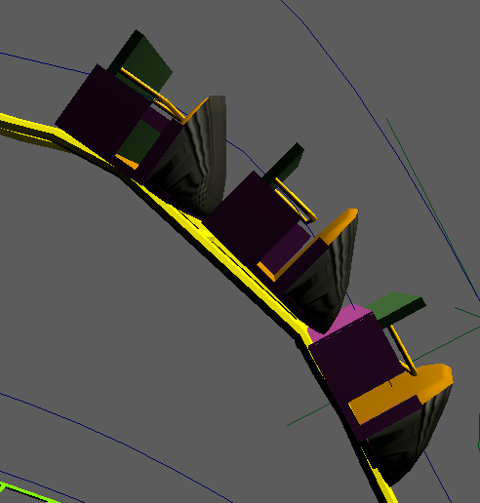 <- Animated cart separately

Note: There are 2 ways to animate the cart separately, 1 would be the detailed way where u go frame by frame to check the location of the cart and adjust it accordingly if needed (Used this method as it looks better)

The 2nd would be to duplicate the locator, the locator path and the original curve by n number of times (n is the number of carts), set each of the locator and path at a different starting location (1 behind the other) and animate it the same way. This method would be faster however the curves would need to be exactly on point to get the ideal look and this would be hard to manipulate.

Although the 1st method is more tedious, it produces a better effect as the carts would always be at the ideal position.

Step 14: Add lights and camera

Step 15: Take screenshot

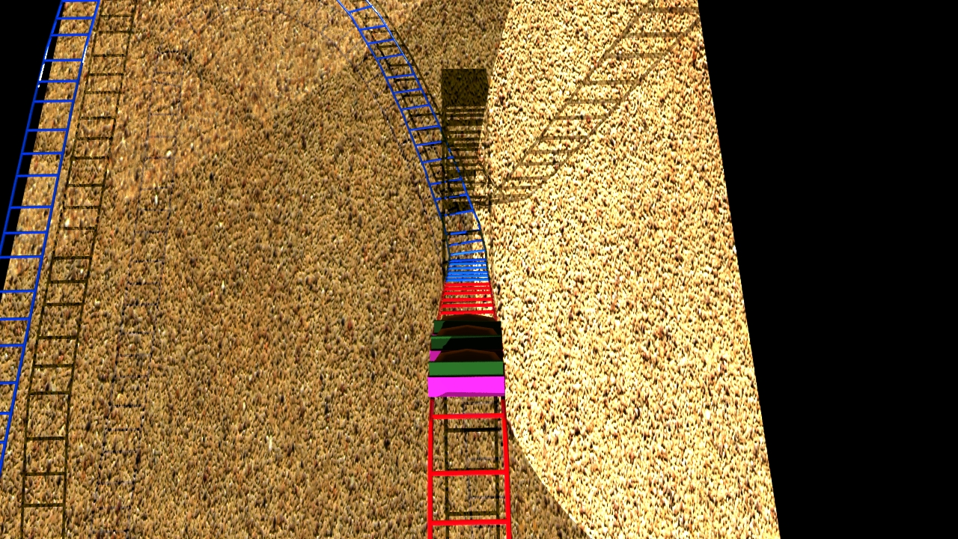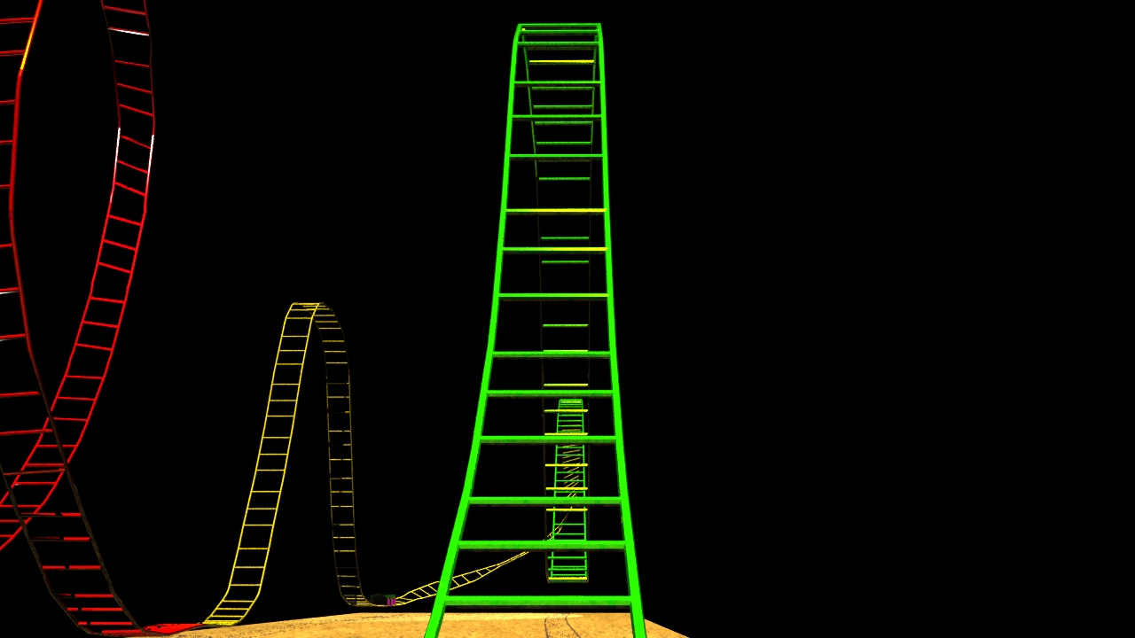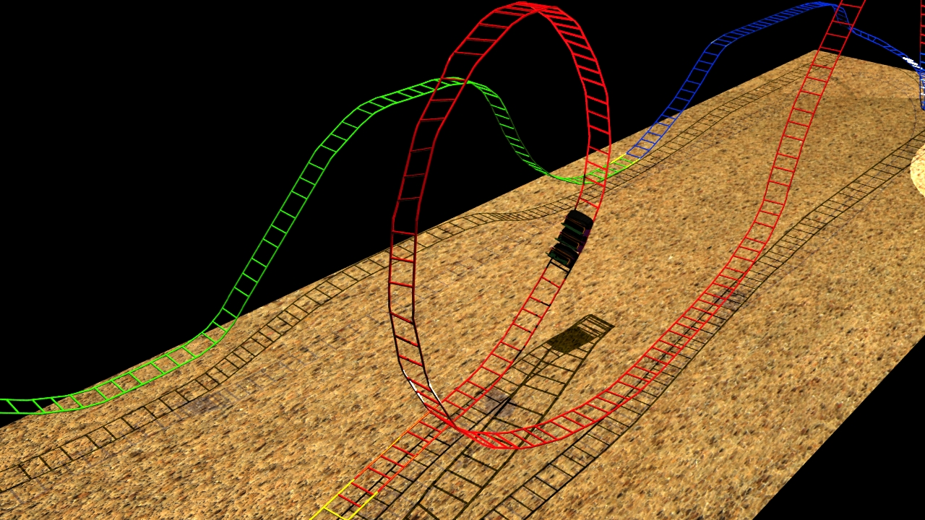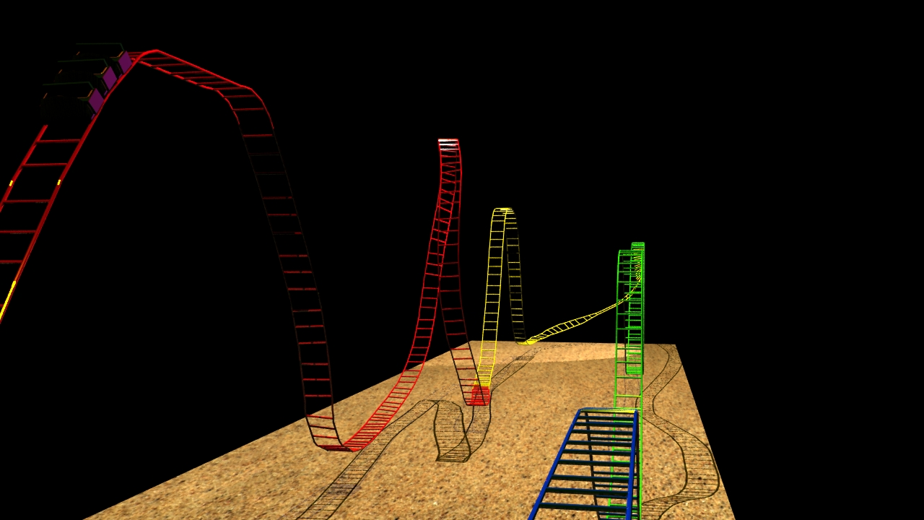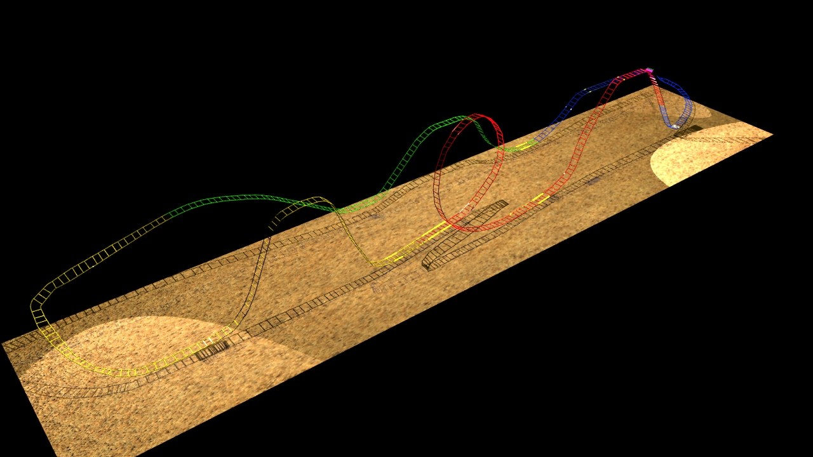

Carbon fiber texture (hood of cart)

<http://bgfons.com/download/1879>

Sand texture (ground)

<http://bgfons.com/uploads/sand/sand_texture1033.jpg>